**Your child may be starting their journey to secondary school soon.** The aim of this guide is to support you with their safety to and from school - for some children, this will be their first regular independent journey.

At this stage in their life, many children gain a lot of independence without having the experience and skills to be able to keep themselves safe. Unfortunately, our statistics show a spike in child pedestrian casualties at 11 years of age and although some children often think that they ‘know it all’ and don’t need to think about road safety, it is so important that they are made aware of the increased risks that they will face and how vulnerable they are on their new independent, unfamiliar journey.

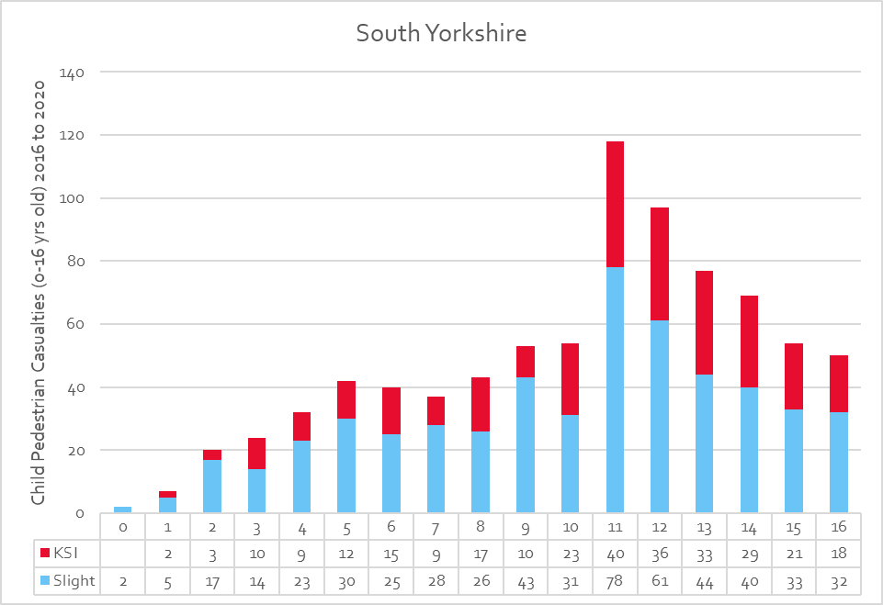

It is important both you and your child know when they have the skills and are ready to travel independently and safely, and it is a good idea to start to think about your child’s new journey with them well beforehand.

* Talk to them about how they feel about their new journey.
* If possible, do the journey with them before term starts.
* Think about potential hazards.
* Make sure they have contact numbers of family and friends in case of emergency.

**The start of secondary school is the perfect time for your child to establish safe and sustainable travel habits that will stay with them for the rest of their life!**

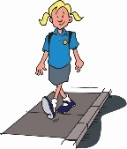**Walking**

Once they start secondary school, your child is likely to be walking alone or with friends, so they need to have the skills to do so safely

* Plan a safe route with your child. Google maps is a great tool to use where you can also get a street view to explore at street level and find pedestrian crossings, bus stops etc.
* Encourage independence and good/safe decision making, like choosing safer places to cross, especially on busy routes or where there are parked cars
* Friends can be a big distraction and peer pressure can lead to risk taking. Highlight the potential dangers of messing about close to busy roads and discourage it.
* Encourage them to use pedestrian crossings and remind them that they still need to check that traffic from all directions has stopped before crossing even when the green man is showing.
* Children who are late often take more risks – help your child get into the habit of getting their things ready the night before and leaving plenty of time to walk to school.
* Shortest route isn’t always the safest route – shortcuts may not be as safe.
* Remind your child that although they know how to cross safely it only takes a split second for mistakes to be made and therefore stress the importance of not being distracted.

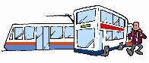**Public transport**

If it’s too far for your child to walk or cycle to school, using public transport is a great next option (or the ‘school bus’ if there is one), however your child may not be used to travelling by public transport on their own, so there are a few things to consider:

* Travel pass – apply for a Mega Travel Pass online, for a reduced fare on public transport [https://www.travelsouthyorkshire.com](https://www.travelsouthyorkshire.com/megatravelpass/)
* Identify which bus they will need for each journey and where the bus stops are – maybe introduce a route planning app for their phone – <https://travelsouthyorkshire.com/en-gb/journeyplanning/smartphone-apps>
* It might be a good idea to do a practise run with your child before they start in September
* Ensure your child understands the importance of waiting until the bus has pulled away from the bus stop so that they can see in all directions before crossing.

**Top tip**: It’s a good idea to take a photo of your child’s bus pass. If lost, you will have the pass number and details handy to request a replacement

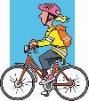

**Cycling**

Cycling could be another option for your child to get to school. Together with your child plan the safest route and make sure they have the correct safety equipment to wear such as a helmet and bright/reflective clothing. Also a few quick reminders :

* They need to recognise and obey traffic signals; the Highway Code applies to cyclists as well.
* Be aware of the dangers of blind spots and know never to cycle up on the inside (left) of large vehicles. They could turn left across the path of a cyclist without seeing them.
* If they are going to be riding on a shared pedestrian/cycle path remind your child of the need to respect pedestrians and give way to them if necessary.
* Make sure that their bike is well maintained and fitted with a bell, reflectors and with a white light at the front and a red one at the back (if they will be cycling when it is dark) - it’s the law!
* Does your child know how and where they will leave their bike securely when they arrive at school?

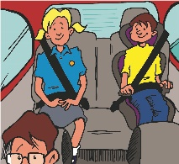

**Traveling by car**

This may not be new to your child, but just a few reminders of how you as a driver and your child can be safe :

* Inconsiderate school-gate parking generates the greatest number of school-transport related complaints and creates danger for everyone. Perhaps drop your child off a bit further away, so that they can reap the many benefits of walking part of the way? You could even drop them at a friend’s house or central meeting point so they can walk in together.
* Make sure your child knows how to get out of the car and cross the roads safely. They should always get out on the pavement side, not into the road
* Unfortunately, people are less likely to use seat belts on short or familiar journeys, just like the school run. Don’t let anyone travel in your car while not wearing their seatbelt and make sure that your child will always wear one when travelling with other people.
* Alert your child to the dangers of crossing between parked cars. They could be masked by the vehicle so drivers don’t see them.